Task 3  
Machine Learning IUP

Ahnaf Muhammad Alfariza  
16/395991/PA/17332

Implement K-Fold Cross validation using iris data with learning rate 0.8 and 0.1.

Cross-validation is a statistical method used to estimate the skill of machine learning models by partitioning data into subsets. Cross validation will give us more accurate estimate of model’s performance. Usually cross validation is used for comparing the machine learning model in different methods to see how well the model perform in practice.

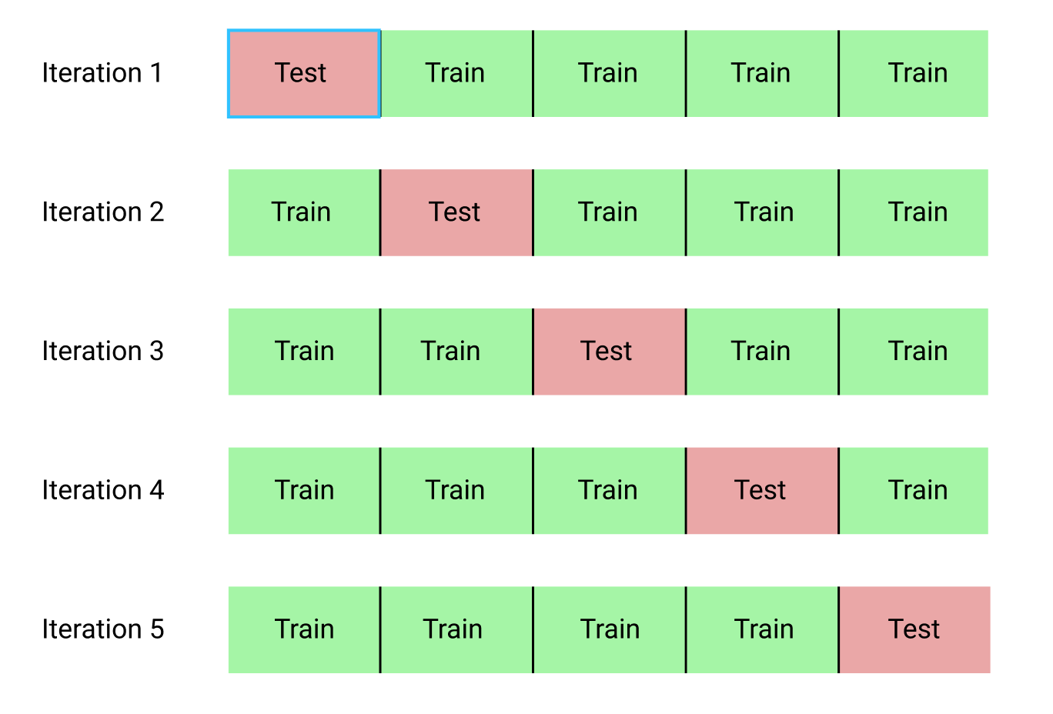One of the cross-validation techniques is k-fold cross validation. In k-fold cross validation, we split the data into k equal sized sub-data. In the sub-data, we use a single sub-data for testing data and k-1 sub-data for the training data. In this case, I use k=5, thus, 5-fold cross validation, the single sub-data is used for testing and 4 other data is used for training.